|  |  |  |  |  |  |
| --- | --- | --- | --- | --- | --- |
| Home | Our Products | Our Clients | Career | About us | Contact us |
| 1st page | | | 2nd Page | | |

### ****1. Home****

Welcome to **Biz Flow**—where innovation meets business.

We specialize in:

* **SaaS-based Web Services:** Streamline your operations with cutting-edge solutions tailored to your business needs.
* **Mobile Applications:** Engage your audience with user-friendly, high-performing apps designed for the future.
* **Software Consultation:** Expert guidance to optimize your software development and technology strategies.
* **Startup Coaching:** Transform your business idea into reality with mentorship and actionable insights.
* **Programming Courses:** Advance your skills with our **Intermediate to Advanced-level courses** that cater to professionals aiming for excellence.

Let’s make your business flow seamlessly with technology that works for you.

### ****2. Our Products****

#### ****Track-Bill** <https://track-bill.com/>**

Effortlessly manage and monitor your bills with **Track-Bill**—a versatile platform designed to keep your finances in order. Whether you're tracking personal expenses or managing business transactions, Track-Bill simplifies bill management with its intuitive interface and powerful analytics.

Discover the full potential of this product and revolutionize the way you handle finances.

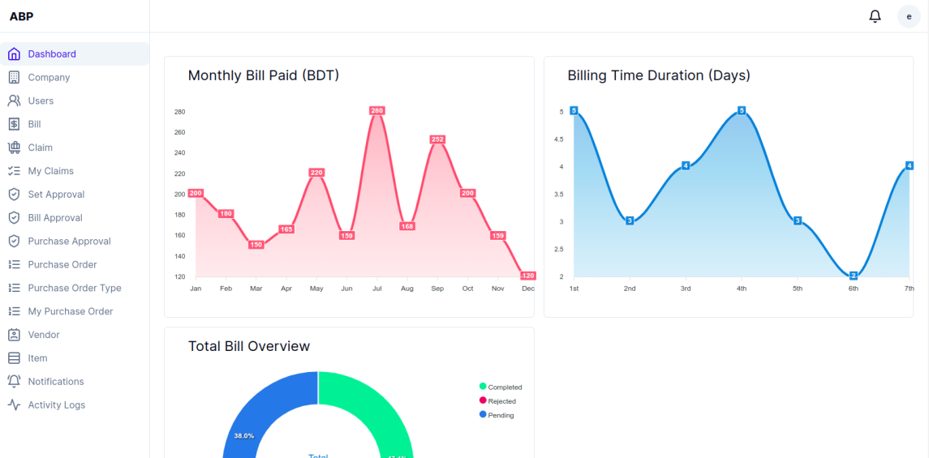

Stay tuned for more innovative tools from **Biz Flow**, designed to empower your business every step of the way.

#### ****Bill Management****

Simplify your financial operations with our **Bill Management and Bill Claim Software**. Effortlessly organize, track, and process your bills in one secure platform. Streamline claims with automated workflows, reducing errors and saving time. Empower your business with accurate, hassle-free financial management!

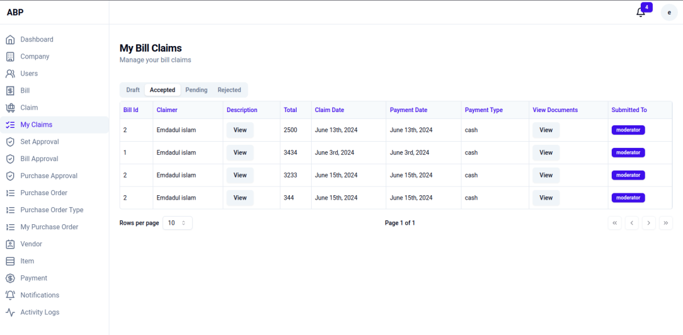

### ****Our Clients****



### ****Career****

Join the **Biz Flow** team and shape the future of business technology!

We’re on the lookout for passionate and talented individuals to grow with us. Explore exciting opportunities in:

* **Junior Web Developers:** Kickstart your career by building dynamic and responsive websites with modern tools and frameworks.
* **Senior Programmers:** Lead complex projects, solve challenging problems, and mentor the next generation of developers.
* **Figma Developers:** Design stunning, user-centric interfaces that enhance user experiences across web and mobile platforms.
* **AI Model Developers:** Innovate and implement AI-driven solutions to revolutionize business processes.

If you’re ready to make an impact and thrive in a collaborative, innovative environment, we’d love to hear from you. Let’s build something extraordinary together!

**Drop your CV** and become part of the **Biz Flow** journey!

Upload CV

|  |
| --- |
| Choose File |

### ****About us****

|  |  |
| --- | --- |
| **Mohiuddin Hyder Khan**  Former head of IT, pedrollo nk limited  MBA in digital technology management, royal roads University, british colombia, canada  24 years experience on computer programming, system design, system implement, ERP  Contact No: +8801919-216460 | **Dr. Aasim Ullah**  Assistant Professor, Department of Electrical and Electronic Engineering (EEE), International Islamic  Ph.D. in Electric Power Engineering, School of Engineering, Computer & Mathematical Science. Auckland University of Technology, New Zealand.  MSc in Electric Power Engineering, Norwegian University of Science & Technology, (NTNU), Norway  Contact No: +8801911-060435 |
| email: [bizflow@proton.me](mailto:bizflow@proton.me)  Address:  **Cittagong:** 299, Nabab Siraj Ud Dawllah Road, Chandanpura, Chittagong.  **Dhaka:** Flat-C/1, Building 4, Joynogor Apartment Complex, Mirpur-13 | |

© Biz Flow. All rights reserved.